**PROJECT : QUARANTINE CENTRE**

**DETAILS OF THE DATABASE SCHEMA**

**THIS DOCUMENT CONTAINS DETAILS OF DATABASE SCHEMA WHICH WE HAVE USED IN OUR PROJECT, WITH THE DESCRIPTION OF EACH TABLE AND ATTRIBUTES DATA TYPE.**

**ALSO IT INCLUDES THE DETAILS OF THE STORED MEANINGFUL DATA INSERTED IN THOSE TABLES IN TABULAR FORMAT, WITH THE HELP OF SNAPSHOTS.**

**NOTE :**

**THE DATA ENTERED IS IMAGINARY.**

**THE PRIMARY KEY FOR ALL TABLES IS “ID”.**

* **ACCESSING THE DATABASE AND TABLES:**

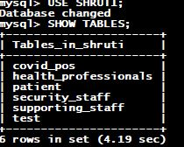

**THE DATABASE CONTAINS 6 TABLES NAMELY:**

(DESCRIPTION OF TABLE FOLLOWED BY ENTRIES IN THE TABLE)

1. **PATIENT** : IT CONTAINS DETAILS OF PATIENTS ARRIVED AT CENTRE.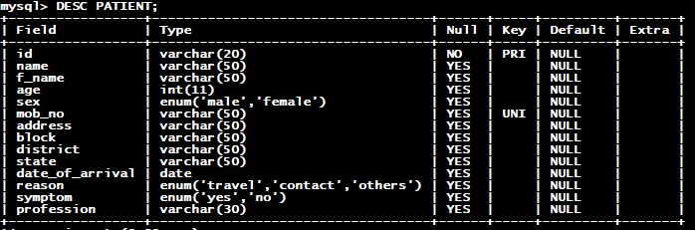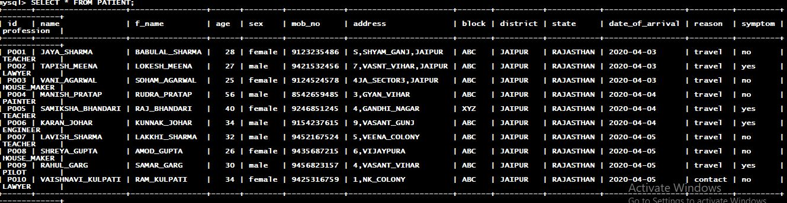
2. **HEALTH_PROFESSIONALS**: IT CONTAINS THE DETAILS OF HEALTH PROFESSIONALS IN THE CENTRE.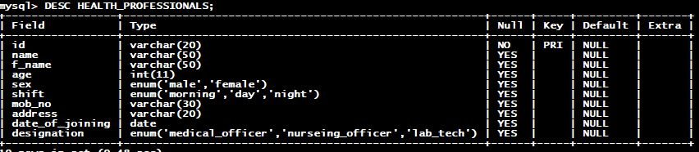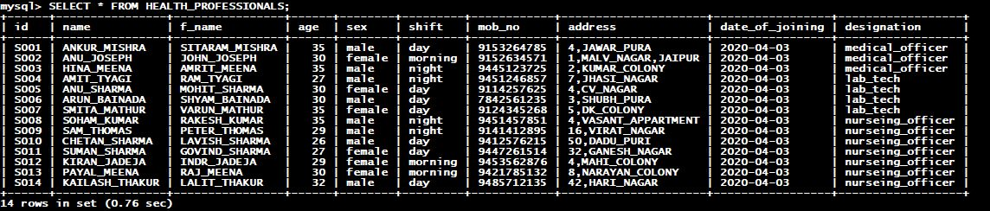
3. **SECURITY_STAFF** : IT CONTAINS THE DETAILS OF APPOINTED SECURITY STAFF.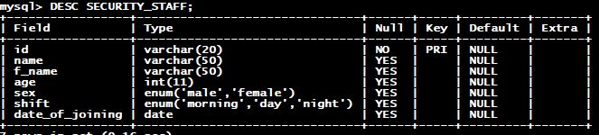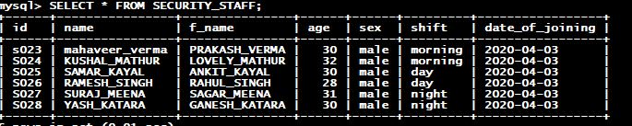
4. **SUPPORTING_STAFF** : IT CONTAINS THE DETAILS OF SUPPORTING STAFF FOR THE PURPOSE OF CLEANING AND SANITIZATION.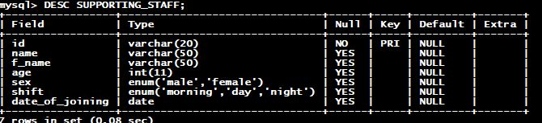
5. **TEST** : THIS TABLE CONTAINS THE DETAILS OF PATIENTS WHOSE TEST HAS BEEN DONE AND THEIR RESULT.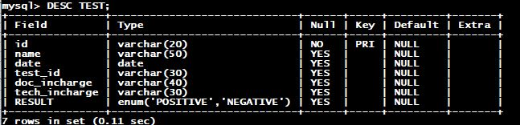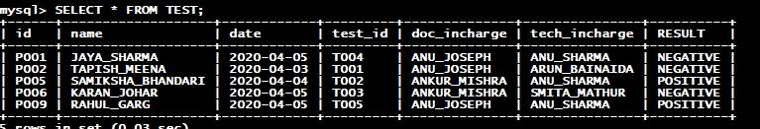
6. **COVID_POS** : THIS TABLE CONTAINS DETAILS OF PATIENT THAT HAS BEEN TESTED POSITIVE.

